Anthony Russell

December 1, 2017

CSC 174 Bronx IA

Assignment 9

The website our team has created is for the purpose of determining how popular certain cat breads are most popular, and what people thoughts are towards those breads.

Survey = a list of questions to be answered by the users

Response = the answers to those questions that should only be seen by admins

Assts

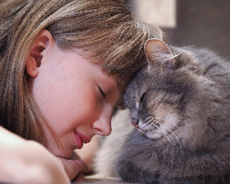

A pet or companion animal is an animal kept primarily for a person's company, protection, or entertainment rather than as a working animal, livestock, or laboratory animal. Popular pets are often noted for their attractive appearances, and their loyal or playful personalities. Pets provide their owners (or guardians) physical and emotional benefits.

A cat is regarded as many to be the premiere companion; they are low maintenance, fun to snuggle, and catch mice in your house. There are numerous debates over which cat breed is in fact the American favorite. Is it the Ragdoll? The Maine Coon? The Siamese? This survey aims to understand how many pets our users currently possess and of what kind.

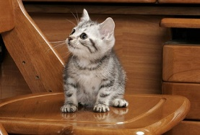

American Shorthair

The adaptable and good-natured American Shorthair retains his hunting ability, but these days he is more likely to be a family companion. Learn more about American Shorthairs.

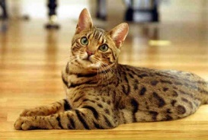

Bengal

The Bengal could never be called delicate. It is an athlete: agile and graceful with a strong, muscular body, as befits a cat who looks as if he belongs in the jungle. Learn more about Bengals.

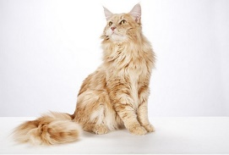

Maine Coon

The Maine Coon is a native New Englander, hailing from Maine, where he was a popular mouser, farm cat and, most likely, ship’s cat, at least as far back as the early 19th century. Learn more about Maine Coon.

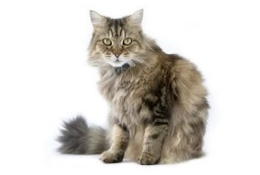

Ragamuffin

The Ragamuffin is known for his docile nature. He loves to be held like a baby and will completely relax into your arms. Learn more about Ragamuffins.

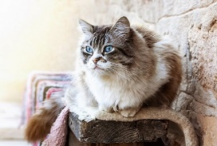

Ragdoll

With positive reinforcement, Ragdoll cats learn quickly and can pick up tricks as well as good behaviors such as using a scratching post. Learn more about Ragdolls.

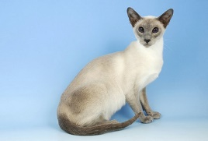

Siamese

The sophisticated Siamese looks dressed for an elegant masquerade ball in pale evening wear with chic black accessories and tanzanite-blue eyes. Learn more about Siamese cats.

Layout

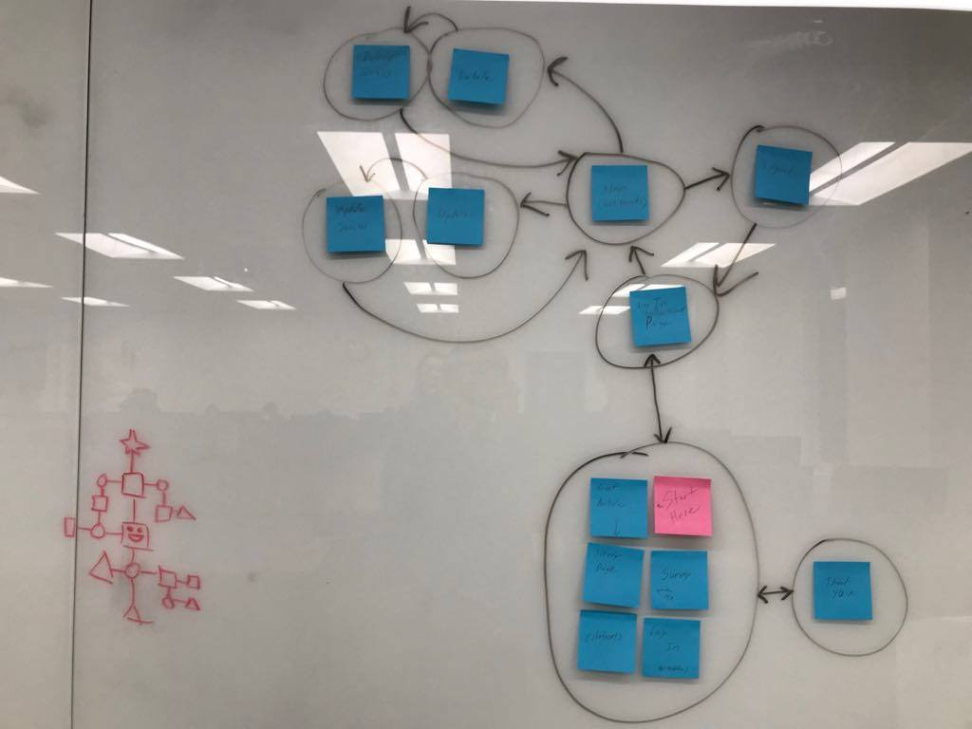

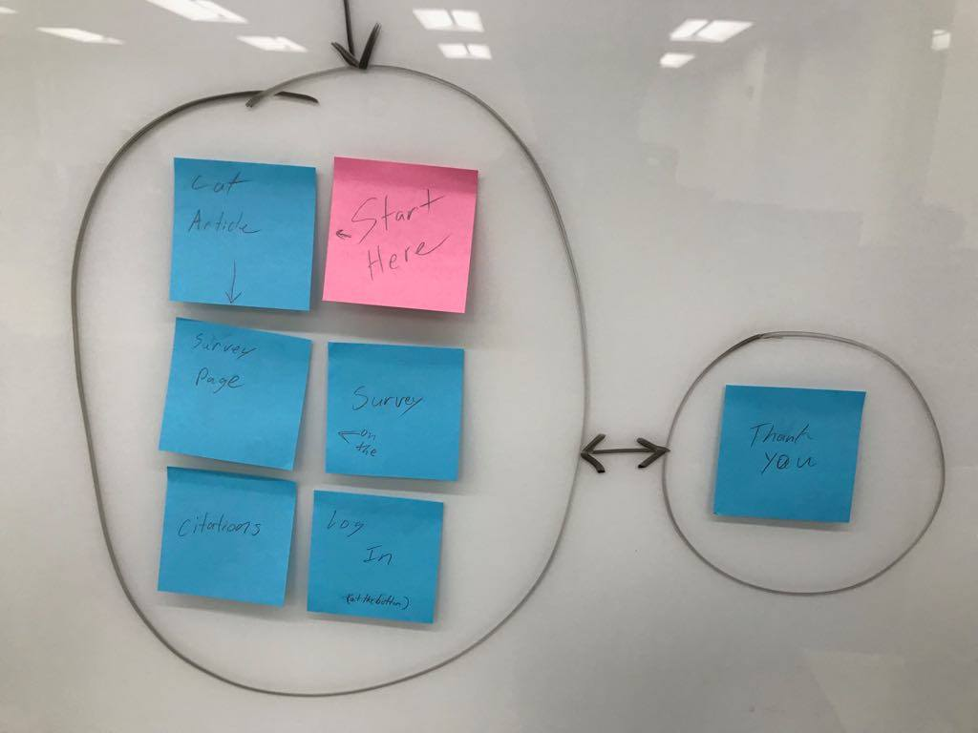

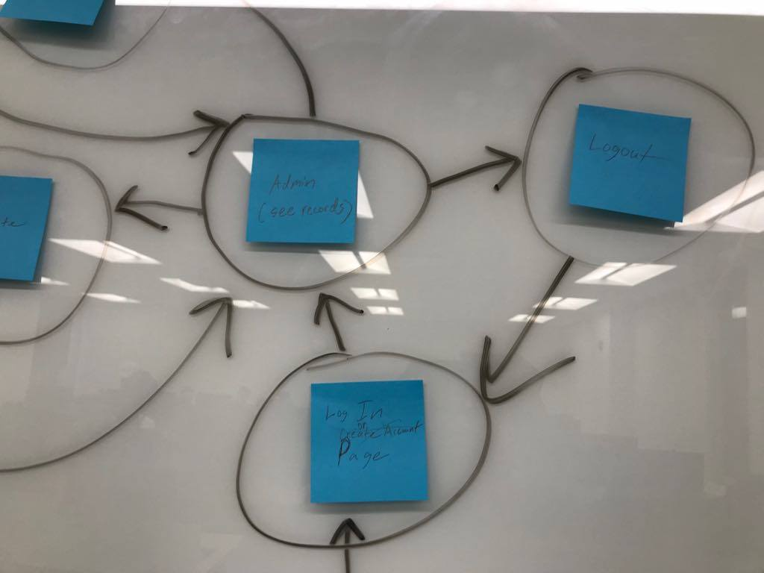

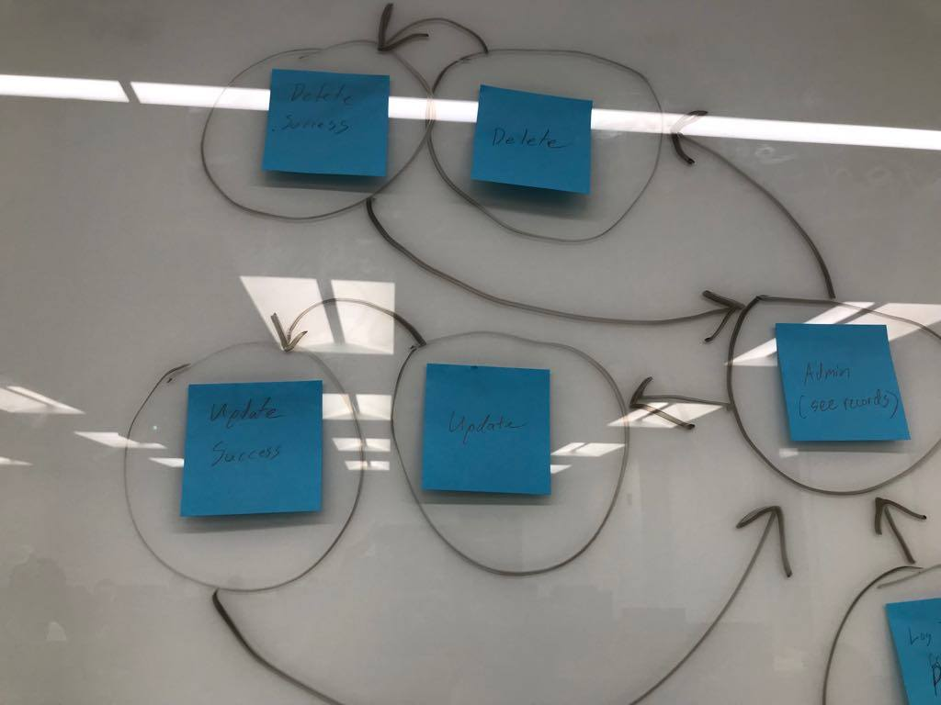

Choreography

A user would start on the page with the survey. From there they can immediately see survey and will fill it out. By the time they get to the bottom of the survey they will also be at the bottom of the page. This is where the submit button is. Once they submit they will be taken to a thank you page which has a button that goes back to the survey. Hidden away at the bottom of the survey is ant admin login which goes to the login page. On the login page admins can either log in or be taken to the sign up page where they can create a new account. Doing either will take them to the page were they can view the entire database for the survey responses. This part of the website has a nave bar on every page which allows them to directly go home (to the table view page), to the survey, to the delete page (where survey results can be deleted), and to the update page (where survey results can be updated).

Description

Since this is a website about cats it’s meant to cute and fun to look at. It’s not too serious on the user side, and also has a homey feel to it.

My Plan

As the AI I gave my team very specific instructions to follow for improving the website. I uploaded this to GitHub roughly 3 days after the assignment was sent out ( <https://github.com/Graymizu/CSC174-Assignment09> ). It was my plan for the site, however I had some trouble getting some people in my group to start as early as I did/even look at the rubric that I made. I still feel as though it is important to this document though.

CSC174 Assignment 9

City: Bronx

IA: Anthony Russell (IA)

Designer: Adam Struhl (DS)

Frontend Coder: Estella Kim (FC)

Backend: Lulu Chen (BC)

Things that should be added our changed for Assignment 9:

Survey Related Page

IA/FC - Make sure that appropriate fields are required

IA/FC - Add navigation button to the "thank you message" to get back to the survey

IA - Add more content to the survey

FC/BC - Make sure that the new info is properly connected to the database (FC-> PHP, BC-> SQL query & Bluehost database)

DS - Design website based off of the colors in the new picture at the top of the survey page

DS - Give the website a playful font the matches the theme of cats

Admin Related Pages

IA/FC - Create a nav bar that sticks to the top of the screen [Home=admin, Survey, Update, Delete, Logout]

FC - Make the database display on the admin page stay a constant size and scrollable by using JavaScript

DS - Give these pages a more professional looking font

FC/BC - Delete.html and Update.html should have a less detailed view of the database so the user doesn't have to remember what account they wanted to select

(Should show at least name and email. Could also show familiarity with each cat bread)

FC/BC - The Delete and Update functions should let the user know if there wasn't nothing to deleted [Sorry, account #_ does not exist :( ]

FC/BC - When updating an account, the survey should be populated with the accounts original answers

Login/Logout

BC - Create the "user" database based off the login code that was already uploaded

DS - Could you use the "cat-log.jpg" on the login and logout page

(either as a background image or something similar to what the Facebook login page looks like)

FC - Go through the php login code to make sure everything works smoothly